**Boolean Matrix**

* Useful for representing other structures.
* *E.g.*, relations, directed graphs (later on)
* All elements of a *zero-one* matrix are either 0 or 1.
* E.g., representing **False** & **True** respectively.
* The **join**of **A**, **B** (both *m* × *n* zero-one matrices):

**A** ∨ **B** = [*aij* ∨ *Bij*]

* The **meet** of **A**, **B**:

**A** ∧ **B** = [*aij* ∧ *bij*] = [*aij bij*]

**Join and Meet Example**

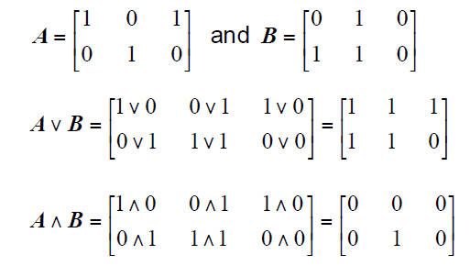

**Boolean Product**

* Let **A** = [*aij*] be an *m* × *k* zero-one matrix and **B** = [*bij*] be a *k* × *n* zero-one matrix,
* The ***Boolean Product*** of **A** and **B** is like normal matrix multiplication, but using instead of +, and  instead of × in the row-column “vector dot product”:

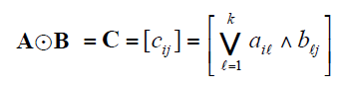

**Example**

